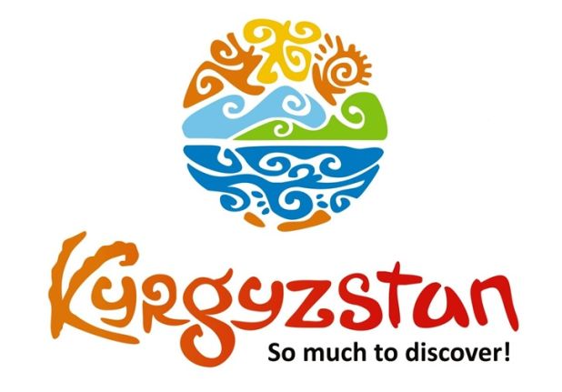**Budget tour to Kyrgyzstan**

Country: **Kyrgyzstan**

Period: **middle of June – September**

**Days: 10 / Nights: 9**

Organizing any complexity of tours to Issyk-Kul, Son-Kul, around Kyrgyzstan and Central Asia. We guarantee you high quality of service and individual approach!

This tour is designed specifically for those people who would like to see the highlights of Kyrgyzstan and prefer to stay in (budget) places where they can meet/get to know closer local people and their culture.

On the days that we're not traveling, there is some flexibility on how to spend your day.

**Day 1: Airport Manas – Bishkek**

Upon arrival to airport meet with a driver and transfer to city of Bishkek.

Independent exploration of the city without guide and driver.

Overnight at a Hostel (check-in at/after 14:00 pm).

Meals: no

**Day 2: Bishkek - Kochkor**

After breakfast, depart to Kochkor village.

On the way visit Burana Tower, a small nearby museum and an open air Balbals (stone figures) – a historical sight remained from Karakhanids period. Upon arrival, accommodation at a local family-run guesthouse/homestay.

Evening free time for independent exploration of village and its surroundings.

Dinner and overnight at a homestay.

Meals: breakfast, dinner

**Day 3: Kochkor – Song-Kul Lake**

After breakfast, depart to Song-Kul Lake – one of the most beautiful mountain lakes in Kyrgyzstan.

You will stay in a yurt camp and get to know nomadic way of life by interacting with local nomads, watching them milk cows and mares.

Overnight at a yurt camp.

Meals: breakfast, lunch-box, dinner

**Day 4: Song-Kul Lake**

Whole day free at Song-Kul Lake. Hiking is available to surrounding mountains.

Song-Kul Lake lies at an altitude of 3016 m, and has an area of about 270 km2 and volume of 2.64 km3. Lake's maximum length is 29 km, breadth about 18 km, and extreme depth of 13.2 m. It is the second largest lake after Issyk-Kul Lake, and the largest fresh water lake in Kyrgyzstan. Its name, meaning "following lake", is popularly considered to refer to this relation. A broad summer pasture and then mountains surround it.

This day's program is flexible, it is up to clients choice how to spend it: hiking or just resting and staying with local nomads.

Meals: breakfast, lunch-box, dinner

**Day 5: Song-Kul Lake – Jeti-Oguz Valley**

After the breakfast, a drive to Jeti-Oguz, a lush valley with some striking red sandstone rock formations, including the “Seven Bulls” from which the valley takes its name.

After some sightseeing, there is a ride to Jeti-Oguz. Accommodation at the yurt camp.

Note: Accommodation conditions at yurt camp are very traditional, meaning that person will be able to share toilet outside of the yurt and be able to experience Kyrgyz rural lifestyle firsthand. Single accommodation is not available, 3-6 pax per yurt.

Meals: breakfast, lunch-box, dinner

**Day 6: Jeti-Oguz Valley**

Spend the whole day in Jeti-Oguz Valley, possibility to do some trekking to the mountains and visit waterfall.

Meals: breakfast, lunch-box, dinner

**Day 7: Jeti-Oguz Valley - Karakol**

After breakfast, depart to Karakol.

Upon arrival, sightseeing tour of the town.

City tour includes: visit beautiful Russian Church made entirely of wood (built without nails), Dungan Mosque (Dungan’s are ethnic minority of Muslim Chinese, moved from the West of China) and Kupecheskiy Proezd street that resembles 19th century old Russian village.

Independent lunch & dinner.

Overnight at a local family-run guesthouse/homestay.

Meals: breakfast

**Day 8: Karakol – Cholpon-Ata**

After breakfast, depart to Cholpon-Ata.

Possibility to spend some free time at the beach (sunbathing, swimming)

Accommodation at hotel.

Dinner and overnight at hotel.

Meals: breakfast, dinner

**Day 9: Cholpon-Ata – Bishkek**

After breakfast, visit open air Petroglyphs Museum and Rukh-Ordo Cultural Center in Cholpon-Ata.

Depart to Bishkek.

Upon arrival to Bishkek, accommodation at hostel.

Free time in the evening.

Meals: breakfast, lunch

**Day 10: Bishkek - Manas Airport**

After breakfast, transfer to Manas Airport for departure flight.

Meals: breakfast

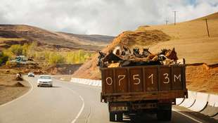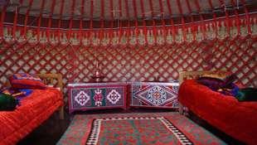

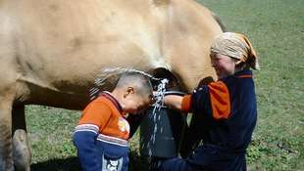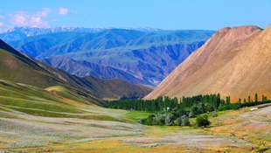

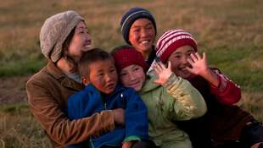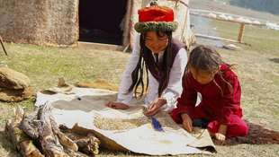

| **GROUP SIZE** | **PRICE IN USD /PER PERSON** |
| --- | --- |
| 2 | 1 445 USD |
| 3-4 | 1235 USD |
| 5-6 | 1025 USD |
| 7-8 | 935 USD |
| Supplementary for single room | 80 USD |

| **PRICE INCLUDES** |  |
| --- | --- |
| Twin based accommodation | Bishkek - hostel (2 o/n) Kochkor - homestay (1 o/n) Song-Kul - yurt camp (2 o/n) Jeti-Oguz - yurt camp (2 o/n) Karakol - homestay (1 o/n) Issyk-Kul - 3* hotel (1 o/n) |
| *Note:* | *Single accommodation is not available at hostels, homestays and at yurt camps,  2-6 pax share one room/yurt.  Conditions at homestays and at yurt camps are basic, but decent and clean.  Facilities (toilet and shower) at hostels are located in the corridor for shared use;  at homestays and yurt camps - facilities are outside at separate section for shared use.* |
| Transport | Land transportation by air-conditioned non-smoking vehicle |
| Local guide services (Eng/Russ) | From Day-2 till Day-9 |
| Meals | Mentioned in the program |
| Entrance fees & excursions | Included |
| Felt show in Tamchy | Included |

| **PRICE EXCLUDES** |
| --- |
| International/domestic flights |
| Invitation letter (if required) |
| Visa fees |
| Early check-in, late/check-out on arrival/departure days (could be arranged upon request for additional fee) |
| Meals other than stated/beverages with meals |
| Personal expenses |
| Tips to guide/driver (optional) |

**Contact information:**

[www.travelscruiser.com](http://www.travelscruiser.com)

Phone (24/7): +996 …………., +996 ……….

E-mail: [info@travelscruiser.com](mailto:info@travelscruiser.com)